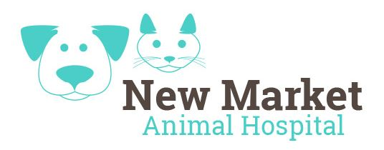 New Market Animal Hospital

**Puppies need frequent veterinary care in their first year of life to ensure maximum health. Our puppy wellness plan saves you money on the total cost of necessary preventive care and treatments. Best of all, this plan features budget-friendly monthly payments—making it easy to manage your puppy’s healthcare costs.**

**$37.95/mo\***

**$46.95/mo\***

*\*Treatments or Medications to go home, after hour emergency services and exams not included\**

*\*Any services requiring sedation will be charged accordingly\**

*\*Services are only available during normal business hours\**

**Puppy Basic Plan**

**includes:**

* **2 Physical Exam**
* **6 Office Visits**
* **2 Intestinal Parasite Screenings**
* **Heartworm Test**
* **Dewormer**
* **Canine Vaccination Series, as recommended:**
  + **3 DAPP**
  + **1 Bordetella**
  + **2 Lyme**
  + **2 Leptospirosis**
  + **1 Rabies**
* **3 Nail Trims**

*If Required, Sedation Not Included*

**PLAN COST $804.89**

**SAVINGS $299.49**

**YOU PAY $505.40**

**FIRST PAYMENT $87.95**

($50 Enrollment fee included in first payment)

**Puppy Advanced Plan**

**includes:**

* **2 Physical Exams**
* **6 Office Visits**
* **2 Intestinal Parasite Screenings**
* **Labwork**

*Includes Complete Blood Count and Full Organ Test*

* **Heartworm Test**
* **Dewormer**
* **Canine Vaccination Series, as recommended:**
  + **3 DAPP**
  + **1 Bordetella**
  + **2 Lyme**
  + **2 Leptospirosis**
  + **1 Rabies**
* **3 Nail Trims**

*If Required, Sedation Not Included*

* **Spay or Neuter**

**PLAN COST $1,1324.39**

**SAVINGS $710.99**

**YOU PAY $613.40**

**FIRST PAYMENT $96.95**

($50 Enrollment fee included in first payment)

**Keep your puppy healthy for less with one of our monthly payment plans**